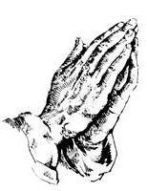
Larry G. Acklin Funeral homes, inc.

newsletter
why pre-arrange??

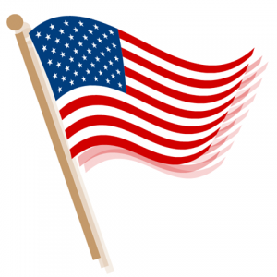ALLOWS YOU TO LOCK IN THE COST
MERCHANDISE AND SERVICES
RELIEVES THE EMOTIONAL STRESS
OF SELECTING MERCHANDISE
(CASKET) DURING AN ALREADY
DIFFICULT TIME
PROVIDES A WAY FOR YOU TO PAY
NOW FOR A FUTURE TIME OF NEED
ELIMINATES FINANCIAL BURDENS
FOR YOUR LOVED ONES YOU LEAVE
BEHIND
ALLOWS YOU TO SELECT EXACTLY
WHAT YOU WANT AND HOW
YOU WANT IT CARRIED OUT
ALLOWS YOU TO PAY A MINIMUM OF
$25.00 PER MONTH UNTIL PAID
IN FULL.
DON’T FOR FORGET TO ORDER YOUR MONUMENT TODAY!!!

may 2017

a message from the president
As we approach Memorial Day, we especially want to remember our veterans for the service they have given. We, especially, want to remember those who have made the ultimate sacrifice for this great country that we are blessed and so proud to be a part of. We encourage everyone to always thank our veterans for their service. For those of us who have loved ones who have gone on to meet their maker, we honor their lives in the most respectful way possible. And, for our families whom we have had the privilege of serving over the years, we have not forgotten your families. We want you to know that we continue to remember you and your loved ones. We say to our families that we love you and we honor your loved ones on this upcoming Memorial Day celebration. We want you to know that you are still in our prayers. May God bless each and every one of you. Please do not hesitate to contact any of our offices if we can answer any questions or assist your family with at any time. Thank you for being a part of the “Larry G. Acklin Funeral Home” family. We are prayerfully celebrating thirty five years of service to Conway, Little Rock, Morrilton, Central Arkansas and the entire State of Arkansas.
Sincerely,
Larry G. Acklin, President
THIRTEEN FOLDS OF THE U.S. FLAG
In honor of the upcoming Memorial Day holiday, we wanted to pay tribute to our veterans who have so graciously and selflessly served our Country. If you have ever attended one of our graveside services wehre the family has requested military honors, then you have witnessed the military personnel playing “Taps” and folding and presenting the U.S. flag to the next of kin. The military personnel folds the flag 13 times. Did you know this? Do you know why? Read below for the Symbols for the Folds of the Flag – Thirteen Folds:
The FIRST fold of our flag is a symbol of life. The SECOND fold is a symbol of our belief in eternal life.
The THIRD fold is made in honor and remembrance of the veteran departing our ranks, and who gave a portion of his or her life for the defense of our country to attain peace throughout the world. The FOURTH fold represents our weaker nature; as American citizens trusting in God, it is to Him we turn in times of peace, as well as in times of war, for His divine guidance.
The FIFTH fold is a tribute to our country, for in the words of Stephen Decatur, “Our country, in dealing with other countries, may she always be right, but it is still our country, right or wrong.” The SIXTH fold is for where our hearts lie. It is with our heart that we pledge allegiance to the flag of the United States of America, and to the republic for which it stands, one nation under God, indivisible, with liberty and justice for all.
The SEVENTH fold is a tribute to our armed forces, for it is through the armed forces that we protect our country and our flag against all enemies, whether they be found within or without the boundaries of our republic. The EIGHTH fold is a tribute to the one who entered into the valley of the shadow of death, that we might see the light of day, and to honor our mother, for whom it flies on Mother’s Day.
The NINTH fold is a tribute to womanhood, for it has been through their faith, love, loyalty and devotion that the character of the men and women who have made this country great have been molded. The 10TH fold is a tribute to father, for he, too, has given his sons and daughters for the defense of our country since he or she was first born.
The 11TH fold, in the eyes of Hebrew citizens, represents the lower portion of the seal of King David and King Solomon and glorifies, in their eyes, the God of Abraham, Isaac and Jacob. The 12TH fold, in the eyes of a Christian citizen, represents an emblem of eternity and glorifies, in their eyes, God the Father, the Son and Holy Ghost.
When the flag is completely folded, the stars are faced upward, reminding us of our national motto, “In God We Trust.”
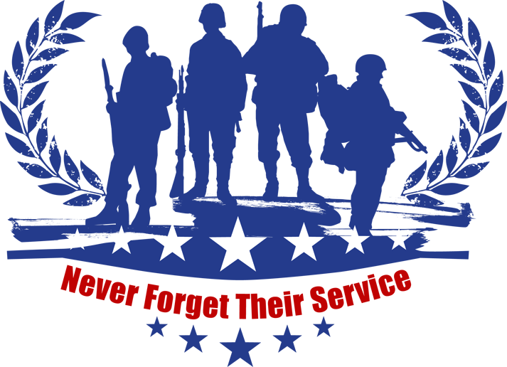
307 N. St. Joseph Street 910 Walnut Street 8821 Colonel Glenn
Morrilton, Ar 72110 Conway, Ar 72032 Little Rock, Ar 72204
501-354-0053 501-327-1124 501-565-1800
www.larrygacklinfuneralhomes.com

